Moralism and Legalism
A Framework for Discernment
Trust Dynamics, Phase Transitions, and the Trajectory of Civilizations
John Pepin
Working Paper — March 2026
“Is your respect for the old merely from a sense of duty? Do you feel the same way about roasted meat?”
— Mencius to Master Kao, on whether moral perception is obligation or recognition
from E. R. Hughes, Chinese Philosophy in Classical Times, p. 99

Abstract
Societies regulate behavior through two fundamentally distinct mechanisms: moral self-governance and legal enforcement. This paper develops a formal dynamical model of the transition between these regimes, grounded in the observation—articulated across twenty-five centuries from Confucius to Bastiat—that when virtue fails, laws multiply. The model decomposes societal trust into a hierarchy: interpersonal trust (P₁), comprising insider trust (P₁ᵢ) and outsider trust (P₁ₒ), and institutional trust (P₂). These interact through asymmetric coupling and undergo phase-transition-like shifts. The framework incorporates trust capacitance, natural trust decay, a self-catalyzing extraction mechanism, counterfeit institutional trust, network islanding dynamics, and the Pareto structure of the legalist apparatus. Laboratory evidence from Milgram’s obedience experiments and Zimbardo’s Stanford Prison Experiment confirms that the moralist-to-legalist transition can be induced in minutes under institutional pressure. The model unifies seven observers across 2,500 years—Confucius, C. S. Lewis, Bastiat, Bonhoeffer, Breitbart, Carneades, and Thrasymachus—as descriptions of different regions within a single dynamical system. It is presented as a framework for discernment, not a prescriptive instrument.

1. The Philosophical Problem
“The more laws and order are made prominent, the more thieves and robbers there will be.”
— Lao Tzu, Tao Te Ching
For as long as humans have organized themselves into communities, they have noticed a tension between two modes of social order. In the first, people cooperate because they possess internalized moral commitments. In the second, people comply because external authority compels them. These are not merely two strategies. They are two distinct regimes of a single dynamical system, separated by a critical threshold: slow at first, then all at once.

2. Seven Observers, One System
Seven thinkers, spanning 2,500 years and radically different traditions, described aspects of the same phenomenon. Each saw the system from a particular position along the trust curve.

2.1 Confucius: Moral example as governance
“If the people be led by laws, and uniformity sought to be given them by punishments, they will try to avoid the punishment, but have no sense of shame.”
— Confucius, Analects 2.3
Confucius observed the high-trust regime. He identified the mechanism by which legalism destroys what it claims to protect: when governed by punishment, people develop strategies for evasion rather than virtue. The law does not merely fail to produce morality; it actively displaces it.

2.2 C. S. Lewis: The primacy of moral formation
“We make men without chests and expect of them virtue and enterprise.”
— C. S. Lewis, The Abolition of Man
Lewis diagnosed early-stage erosion: the destruction of the capacity for moral self-regulation—what this paper calls trust capacitance. Modern education was dismantling the moral formation that produced self-governing individuals.

2.3 Bastiat: Law perverted into plunder
“When plunder becomes a way of life for a group of men in a society, over the course of time they create for themselves a legal system that authorizes it and a moral code that glorifies it.”
— Frédéric Bastiat, The Law
Bastiat stood where legalism had engaged. Law, which in a moral society serves as a scalpel for the rare pathological actor, had become legal plunder. People ceased to distinguish between justice and legality.

2.4 Bonhoeffer: The complicity of the unreflective
“Stupidity is a more dangerous enemy of the good than malice.”
— Dietrich Bonhoeffer, Letters and Papers from Prison
Bonhoeffer’s insight: the vast majority who operate the system without understanding what it does. They are not unintelligent—they are people whose moral reasoning has been captured by institutional authority.

2.5 Breitbart: Culture upstream of politics
“Politics is downstream of culture.”
— Andrew Breitbart
A property emerging at the critical threshold: as the system crosses into legalism, politics expands to fill the regulatory vacuum and culture becomes the contested terrain.

2.6 Carneades: Both regimes in two days
In 155 BCE, the Skeptic philosopher Carneades delivered two lectures to the Roman Senate on consecutive days. On the first day, he argued that justice is real, binding, and the foundation of social order—the moralist position. On the second day, he argued that justice is a fiction imposed by the strong, and that a truly just man would have to sacrifice his own self-interest, which no rational animal would do—the Thrasymachean position. The Romans were so disturbed they expelled the philosophers from the city.
Carneades believed he was exposing a contradiction in the concept of justice. The present model reveals he was doing something more interesting: accurately describing two different states of the same system. His day-one argument is correct in the moralist regime, where high P₁ aligns self-interest with communal interest, making justice feel natural rather than sacrificial. His day-two argument is correct in the legalist regime, where P₁ has collapsed and cooperation is punished by defectors.
Carneades’s error was the same as Thrasymachus’s but more sophisticated: he saw both regimes clearly but mistook them for a philosophical paradox rather than two phases of a dynamical system. And Cato the Elder’s instinct to expel him was, in the model’s terms, the moral suppression term activating in real time—a society defending its P₁ against a perturbation that, if believed, would become self-fulfilling.

2.7 Thrasymachus: Justice as the interest of the stronger
“Justice is nothing other than the advantage of the stronger.”
— Thrasymachus, in Plato’s Republic
Thrasymachus is empirically accurate within the legalist regime and fundamentally wrong about the system as a whole. He never observed a high-trust society. Thrasymachus is right below pₜ. Socrates is right above it.

2.8 The unification
Each observer identified a fragment. The model reveals they were describing the same system from different positions within it—like seven people describing an elephant from different angles, each accurate about what they touched, each incomplete about the whole.
Thinker | Observation | Position in model
Confucius | Moral example governs; law displaces virtue | High-trust equilibrium; displacement mechanism
C. S. Lewis | Moral formation systematically destroyed | Capacitance depletion; early P₁ decline
Bastiat | Law perverted into instrument of plunder | Extraction dynamics; institutions net-negative
Bonhoeffer | The unreflective maintain systems they don’t understand | Actor distribution in legalist apparatus
Breitbart | Politics is downstream of culture | Culture–politics coupling at threshold
Carneades | Justice is real (day one) and fictional (day two) | Both regimes seen; mistaken for paradox
Thrasymachus | Justice is the interest of the stronger | Accurate within legalist regime only

3. The Observer Effect
A framework describing trust dynamics raises an immediate epistemological problem: the observers are not outside the system. Confucius’s teachings built P₁ for centuries. Thrasymachus’s philosophy legitimized extraction. Carneades’s day-two lecture functioned as a P₁ erosion event, which is why Cato expelled him. This paper is no different—it is a perturbation to the system it models.
The problem runs deeper than intellectual influence. The act of measuring trust itself affects trust. When a government conducts trust surveys, it signals to citizens that trust is something the state is monitoring—which is itself a legalist intervention. When institutions create “social cohesion indices” and “trust metrics,” they convert P₁—an organic, informal, lived reality—into an institutional measurement, transforming it into something that lives in P₂ space. The more precisely a legalist apparatus attempts to measure the moral system it is replacing, the more it subjects that system to the very institutional processes that erode it. There is a fundamental limit on how legible interpersonal trust can be made to institutional observation without changing its nature.
The resolution lies in the nature of discernment. Discernment is a capacity that exists only in the presence of moral formation. A person whose conscience is developed gains the ability to see where their community stands. A person without that formation sees equations without significance. The framework is self-selecting: it functions as designed only in the hands of those who do not need to be told not to weaponize it.

4. The Trust Hierarchy
Trust is not a single variable. It decomposes into a layered structure that determines not merely how much trust a society possesses but how widely it distributes.

4.1 Insider trust (P₁ᵢ)
The oldest human trust system. People trust family, clan, tribe, immediate community. The evolutionary default. Generated primarily through family structure: the training ground where individuals first learn reciprocity, delayed gratification, promise-keeping, and the experience that cooperation works. The family is the single most important generator of interpersonal trust—not as an ideological claim but as an empirical observation.

4.2 Outsider trust (P₁ₒ)
When trust extends beyond the tribe, civilization becomes possible. People trust strangers, merchants, neighbors they have never met. This is far more fragile than insider trust.
Outsider trust is generated primarily through religion and culture: shared moral frameworks that extend ethical obligations beyond one’s immediate group. The Golden Rule—treat others as you wish to be treated—appears in Christianity, Confucianism, and Judaism precisely because it is the conceptual engine that transforms tribal trust into civilizational trust. Moral systems that restrict reciprocal obligation to insiders produce strong P₁ᵢ but structurally inhibit P₁ₒ expansion, creating the bounded-trust regime described in Section 10.
Other social practices can contribute to P₁ₒ: civic associations, professional communities, commercial relationships built on repeated honest dealing. But these are expressions of P₁ₒ, not primary generators of it. Professional ethics, for example, is a manifestation of trust—it presupposes a moral framework that makes ethical commitment intelligible. It does not create that framework ex nihilo. The generators remain family (P₁ᵢ), religion, and culture (P₁ₒ).

4.3 Institutional trust (P₂)
Trust in systems rather than individuals. It allows societies to scale beyond what outsider trust can sustain. But P₂ rests on interpersonal trust underneath it. When P₁ collapses, P₂ is living on borrowed time.

4.4 The hierarchy
Total effective trust P = f(P₁, P₂)
Interpersonal trust P₁ = g(P₁ᵢ, P₁ₒ)
P₁ᵢ ← family (primary generator)
P₁ₒ ← religion + culture (extend trust beyond tribe)
P₂ ← built on P₁ substrate
The typical collapse reverses this hierarchy: P₁ₒ declines first, then P₂ expands to compensate, then P₁ᵢ begins shrinking, and finally the society fragments.

5. What Destroys Interpersonal Trust
Six mechanisms erode P₁ and feed the legalist ratchet:
Crime. When crime rises, people avoid strangers, neighborhoods fragment, cooperation becomes irrational.
Corruption. Tells citizens rules apply differently depending on power. Teaches that cooperative norms are for fools.
Lack of opportunity. Social relations become zero-sum. Trust requires that cooperation pays.
Elite hypocrisy. When elites preach rules they do not follow, people infer morality is a tool of control.
Double standards. Two systems of justice destroy trust extremely fast.
Institutional extraction. Bastiat’s legal plunder. When institutions are perceived as extractive, people disengage.
These reinforce each other in a cascade: corruption → elite hypocrisy → double standards → trust erosion → crime → legalism → extraction. The feedback loop is the ratchet.

6. A Minimal Intuition
L = ½[1 + tanh(k(pₜ − P))]
dP/dt = S − νP − εLP
where ν captures natural trust decay and ε is legalist erosion. This system exhibits bistability: two stable equilibria separated by an unstable threshold.
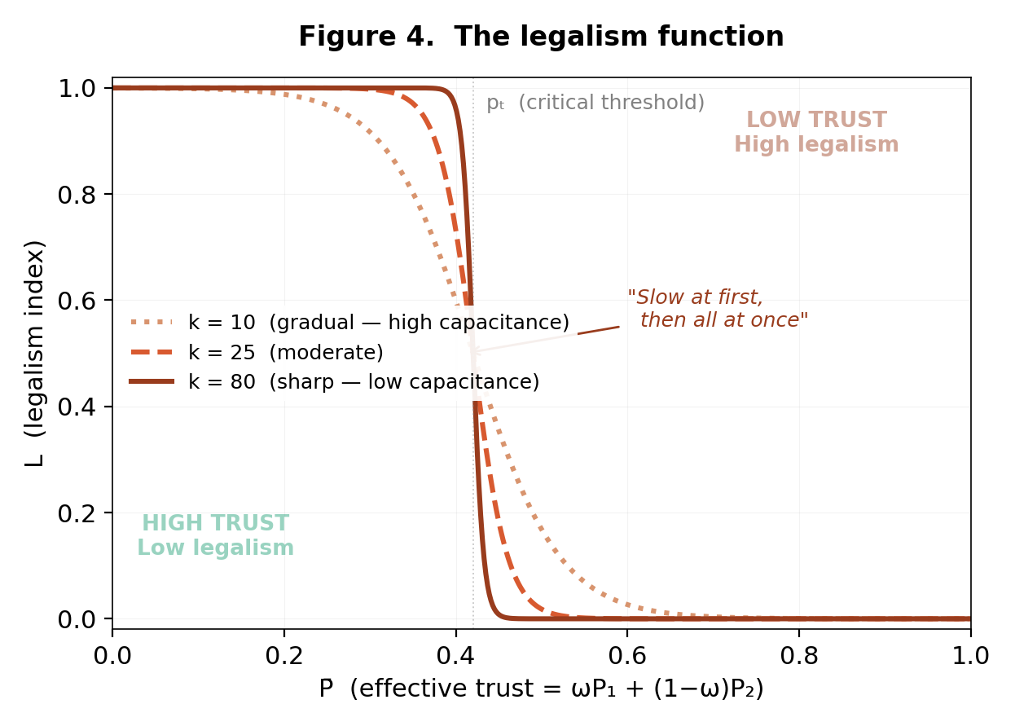

7. The Network Substrate
The dynamical equations presented below are mean-field approximations of an underlying social network process. The network is scale-dependent: at highest resolution, each node is an individual person; at lower resolution, a family; at broadest scale, a community.
P₁ᵢ corresponds to dense local clusters—nodes connected to immediate neighbors. P₁ₒ corresponds to long-range bonds between clusters. The percolation threshold is the point at which enough long-range bonds exist for a giant connected component to span the entire network—the civilizational breakthrough.
Collapse is the reverse percolation transition. Long-range bonds break first. The giant component fragments into disconnected local clusters—islands.

7.1 Islanding and state-dependent parameters
When the network fragments, two critical parameters become state-dependent.
First, effective cultural susceptibility k becomes a function of P₁ₒ. In a connected network, perturbations propagate rapidly—collapse is sharp (high effective k). But on the way back up, the network is fragmented. Trust can regenerate within an island but cannot propagate between islands. Recovery is sluggish (low effective k). The collapse travels through a highway system; recovery travels through a landscape where the highways have been torn up.
Second, the coupling coefficients κ depend on network connectivity. Both κ₁₂ and κ₂₁ require signals to propagate through the network. In a fragmented network, coupling attenuates. Each island interacts with institutions locally but cannot coordinate with other islands.
This provides a structural source of hysteresis independent of capacitance depletion or moral skill atrophy. The network topology itself changes during collapse. The same parameter values that produced rapid collapse now produce sluggish recovery, because the medium through which trust propagates has been destroyed.
Islanding also explains why charismatic capture works specifically in the communitarian quadrant. P₁ᵢ is high (local clusters are strong) but P₁ₒ is low (clusters are disconnected). The charismatic leader provides an artificial long-range bond—people in different islands connect through the leader rather than to each other. The leader isn’t just providing institutional trust; he is providing the network connectivity that P₁ₒ would normally supply. Remove him and the islands disconnect again.

8. The Dynamical System

8.1 A note on methodology
Early versions used second-order dynamics with inertial terms representing cultural momentum. While conceptually appealing, the second-order formulation introduced parameters that could not be empirically grounded and whose effects were largely reproducible through state-dependent coupling. The present version uses first-order dynamics—more transparent, more parsimonious, and sufficient to generate the qualitative behaviors the model predicts.
Similarly, the original parameterization included sixteen independent parameters. Dimensional analysis revealed that many entered the dynamics only as ratios. The present version uses nine dimensionless groups (Section 15), each with a clear interpretation. Over-parameterization is a genuine risk in qualitative systems modeling. The reduced parameter set constrains the model to produce only behaviors that are structurally robust.

8.2 State variables
P₁(t) ∈ [0, 1]: Interpersonal trust. The trust that lets you lend your neighbor tools without a contract, or buy from a stranger at a roadside stand and expect honest measure.
P₂(t) ∈ [0, 1]: Institutional trust. The trust that lets you call the police and expect impartial response, or sign a contract and expect courts to enforce it fairly.
L(t) ∈ [0, 1]: Legalism index (emergent, not free).
C(t) ≥ 0: Trust capacitance.
E(t) ∈ [0, 1]: Extraction rate.

8.3 The legalism function
L = ½[1 + tanh(k(pₜ − ωP₁ − (1 − ω)P₂))] (1)

8.4 Interpersonal trust
dP₁/dt = S(t) − ν₁P₁ − εLP₁ + κ₂₁(E)P₂(1 − P₁) − αE (2)

8.5 Institutional trust
dP₂/dt = κ₁₂P₁(1 − P₂) − ν₂P₂ − μ(1 − P₁)P₂ − βEP₂ (3)

8.6 Trust capacitance
dC/dt = λ min(P₁, P₂) − δLC (4)

8.7 The coupling hinge
κ₂₁(E) = κ₂₁⁰ · (1 − 2E) (5)

8.8 Extraction dynamics
dE/dt = ξ L(P₂ / (P₁ + ε₀)) − φP₁E (6)
The moral suppression term (−φP₁E) is the only endogenous throttle. The system consumes itself—a runaway engine feeding on the only fuel that could slow it down.

9. Laboratory Evidence
The model’s dynamics have been reproduced in laboratory settings, confirming that the moralist-to-legalist transition can occur in minutes under institutional pressure.

9.1 Milgram: P₁ overridden by P₂
Stanley Milgram’s obedience experiments (1961) are a direct test of the P₁ versus P₂ boundary. Subjects were instructed by a man in a lab coat (institutional authority, P₂) to administer escalating electric shocks to a person they could hear screaming in pain. Their P₁—their direct empathic moral perception—screamed “stop.” The institution said “continue.”
Most subjects continued. They reported extreme distress—they sweated, protested, begged to stop—but they kept pressing the button because institutional authority had substituted its judgment for theirs. They outsourced their conscience to the man in the lab coat.
This is the −εLP₁ erosion term operating at the individual level in real time. The legalist frame (the experiment, the authority, the institutional structure) overrides the subject’s capacity to act on their own moral perception. Crucially, the further removed the subject was from the victim—the weaker the P₁ signal—the more readily they complied. P₁ operates through proximity and direct relationship. P₂ operates through abstraction and the diffusion of responsibility.
Milgram is Bonhoeffer’s “stupidity” created in a laboratory in sixty minutes.

9.2 Zimbardo: Regime change in days
Philip Zimbardo’s Stanford Prison Experiment (1971) demonstrates something Milgram didn’t: the speed of P₁ collapse when institutional roles replace interpersonal identity. Zimbardo randomly assigned healthy college students to be guards or prisoners. Within days, guards became sadistic and prisoners became submissive and psychologically broken. The experiment had to be terminated early because it had become genuinely dangerous.
The experiment created a miniature legalist regime from scratch. P₁ was replaced by P₂—institutional roles with formal authority. The “guards” didn’t need prior disposition toward cruelty; the structure produced it by removing the P₁ constraints that normally prevent humans from treating each other as objects.
Several dynamics from the model appeared in compressed form. Extraction emerged spontaneously—guards began using institutional power to extract compliance and humiliation without being ordered to. The ratchet engaged—each act of cruelty made the next one easier. Bonhoeffer’s distribution appeared—a small minority drove the escalation while the majority passively participated. And the few who resisted demonstrated the role of moral formation: their P₁ was strong enough to override the institutional frame.
Together, Milgram and Zimbardo demonstrate that the model’s slow civilizational trajectory—gradual erosion, tanh transition, generational capacitance depletion—is the normal case. Under crisis conditions, the transition can be compressed to nearly instantaneous. The capacitance that normally buffers against rapid change can be bypassed if the institutional frame is strong enough and sudden enough.

10. Regime Taxonomy
P₁ᵢ | P₁ₒ | P₂ | Regime | Characteristics
High | High | High | Moralist | Self-regulation, minimal law. Early Roman Republic, post-WWII America.
High | High | Low | Communitarian | Localist, skeptical of authority. Vulnerable to charismatic capture.
High | Low | High | Bounded trust | Strong clans, limited scalability. Patronage economies.
Low | Low | High | Legalist | Bureaucracy replaces morality. Bastiat’s plunder.
Low | Low | Low | Failed state | Anomie, warlordism. Thrasymachus universally correct.

A sixth configuration—engineered distrust—appears in totalitarian systems (North Korea, the Soviet gulag) where the state deliberately suppresses P₁ᵢ through surveillance, collective punishment, and informant networks. Stable but brittle.

11. The Anatomy of the Legalist Apparatus
The model predicts specific structural properties of the legalist regime that explain its resilience, its self-concealment, and its resistance to reform.

11.1 The Pareto structure
The distribution of actors within the legalist apparatus follows a pattern consistent with Pareto dynamics: roughly 20% of actors in high-leverage institutional positions consciously drive extractive behavior, while roughly 80% are Bonhoeffer’s compliant operators who maintain the machinery without understanding its purpose.
This ratio is not accidental—it is structural. Social and institutional networks tend to approximate scale-free topologies, producing a small number of highly connected hubs and a large number of peripheral nodes. The hubs become the Thrasymacheans: they have the visibility and leverage to understand and exploit the system. The peripheral nodes become Bonhoeffer’s operators: they see only their local connections and follow the signals they receive.
The implication: the legalist apparatus does not need to corrupt 80% of the population. It only needs to place the right 20% in high-leverage positions and let the network structure do the rest. The 80% comply not because they’ve been morally corrupted but because their position in the network gives them insufficient information and insufficient leverage to resist.

11.2 The extrapolation error
Why does P₂ stay high while P₁ is already eroding? Because the average person projects their local trust experience onto the institutional layer.
The average person’s daily experience is dominated by their P₁ᵢ network—neighbors, coworkers, church community. And those people are mostly good, decent, and honest. That’s real. So the average person generalizes from their sample: the people I know are decent, therefore people in general are decent, therefore the people running things are probably decent too.
This extrapolation is rational given the information available—and catastrophically wrong. Not because most people in institutions are evil, but because of the Pareto dynamic. The 80% of institutional actors who are decent are not the ones driving the system. The 20% in high-leverage positions operate by different rules, and the average person never sees them, never interacts with them, and has no direct evidence of their behavior.
This is why trust collapse feels so sudden. P₂ stays high because the average person’s local experience keeps confirming “people are good.” Then something pierces the veil—a scandal, an undeniable double standard—and the update isn’t “one institution is corrupt.” The update is “my entire method of estimating institutional trustworthiness was wrong.” That’s a paradigm shift, not an incremental adjustment, and it happens fast.

11.3 Cultural capture
The path to influence in cultural production—film, television, music, publishing, academia—runs through institutions. Studios, networks, labels, universities, funding bodies, and awards organizations filter who reaches a mass audience. The people who survive that filtering are, almost by definition, people who are comfortable within institutional structures and who have been rewarded by them.
This is a P₂ selection effect. The cultural elite is not randomly sampled from the population. It is populated by people who succeeded within legalist structures—who navigated bureaucracies, pleased committees, secured funding, and won approval from other institutionally successful people. Their entire lived experience tells them that institutional systems work, because institutional systems worked for them.
So when they create stories, they naturally frame problems as requiring institutional solutions. The hero calls the authorities. The wise character is the expert. The villain is the person who distrusts institutions. When communities solve their own problems, it’s framed as quaint or temporary. This is not conscious propaganda in most cases. It is the natural worldview of people whose lives have been shaped by institutional success.
The ratchet operates through this cultural layer: legalism produces institutional concentration of power, which controls cultural production, which normalizes legalism. Breitbart’s observation becomes the mechanism of its own reinforcement.

12. Historical Mapping

12.1 The Fertile Crescent: Collapse without recovery
The Bronze Age civilizations of the Fertile Crescent represent the longest test of the hysteresis prediction. Each successor civilization arose on the same geography with access to the same resources, yet none reconstituted the trust structures of its predecessor. The rivers still flow. The soil is still fertile. What was lost was the trust infrastructure.

12.2 Germany: The complete cycle
Weimar Germany (1919–1933): P₂ collapsed while P₁ᵢ remained intact. The communitarian quadrant—vulnerable to charismatic capture.
Nazi Germany (1933–1945): Hitler reconstituted P₂ through charisma. Counterfeit—entirely load-bearing on one personality. The islanding insight explains the mechanism: the leader provided artificial long-range bonds between disconnected community clusters.
Post-war Germany (1949–present): Because P₁ᵢ survived, the substrate for organic P₂ rebuilding was intact. Post-war Germany built the most deliberately decentralized institutional structure in Europe—a conscious rejection of charismatic P₂.

12.3 Argentina: The ratchet in reverse
Peronist Argentina sat deep in the legalist quadrant: massive regulatory apparatus, institutional extraction through hyperinflation, bureaucratic expansion. Argentina under Javier Milei (2023–present) represents a rare attempt to reverse the ratchet—lowering L and E simultaneously through deregulation, fiscal austerity, and elimination of inflation-based extraction.
P₂ has risen sharply: government confidence nearly doubled from 24% (2023) to 43% (2024). P₁ₒ is being rebuilt as deregulation forces cooperation back into the interpersonal sphere—every transaction that used to flow through bureaucracy and now goes directly between people is a new edge in the trust network.
As a discernment exercise, Argentina in early 2026 presents a mixed but encouraging picture. P₂ aggregate trust has reached approximately 48–50% on the Edelman Trust Barometer. Direct measures of P₁ₒ lag—WVS Wave 8 is ongoing. The verdict: genuine counterclockwise movement, the furthest from the legalist quadrant in decades, but fragile until P₁ and capacitance catch up.

12.4 Italy under Machiavelli: Self-reinforcing distrust
Machiavelli described Renaissance Italy—the peninsula as a political system—as profoundly corrupt. P₁ and P₂ both near zero, with distrust as the rational strategy. The failed-state attractor. Italy’s persistent fragmentation for centuries is consistent with the hysteresis prediction.

13. Simulated Trajectories
P₁ erodes gradually while P₂ remains high. Then the cascade: legalism spikes, extraction surges, P₂ crashes.
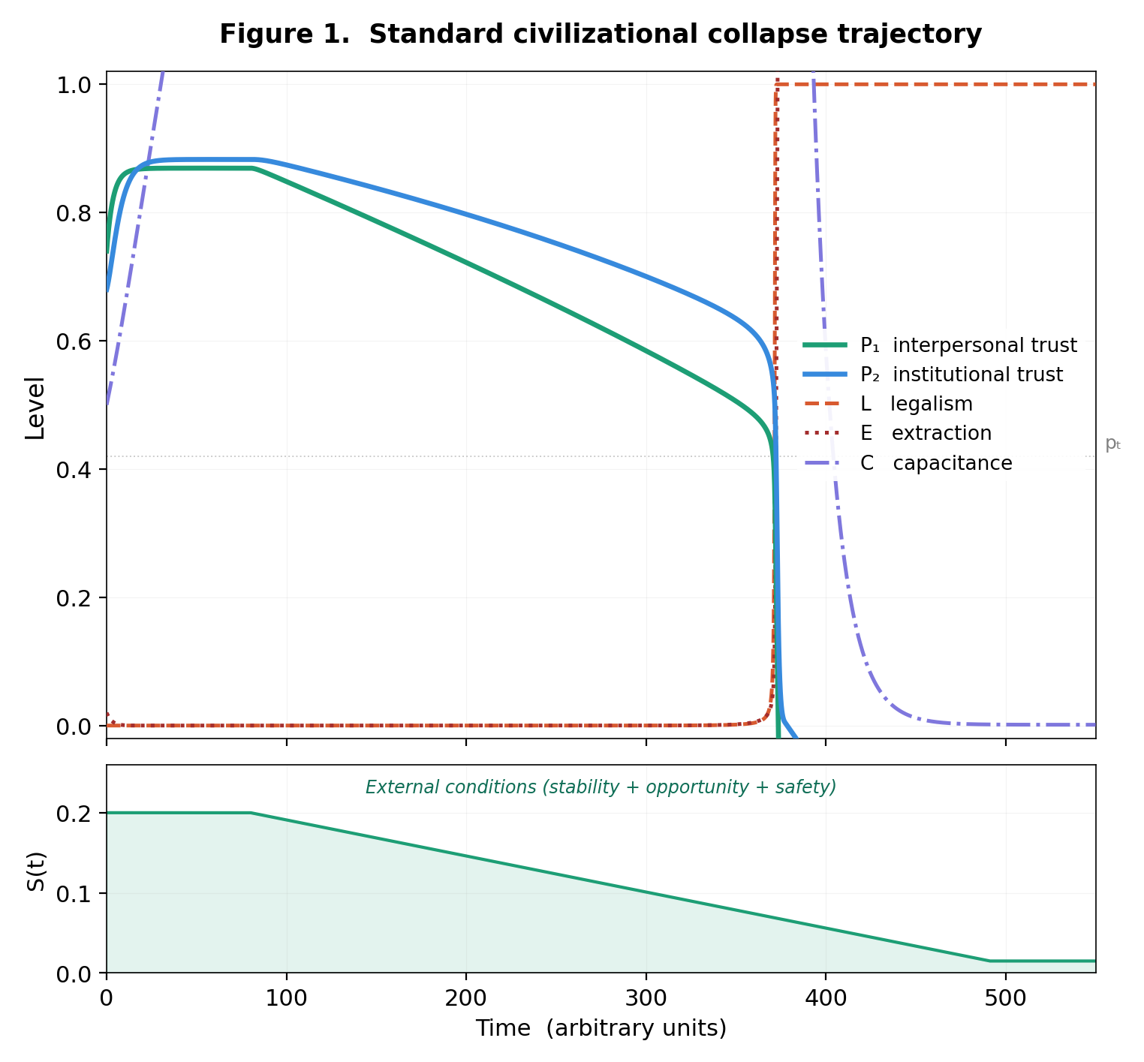
Phase portrait: the trajectory through four-quadrant space.
Counterfeit trust: charismatic capture and crash. When P₁ remains strong, the system recovers—confirming P₁ is the substrate.
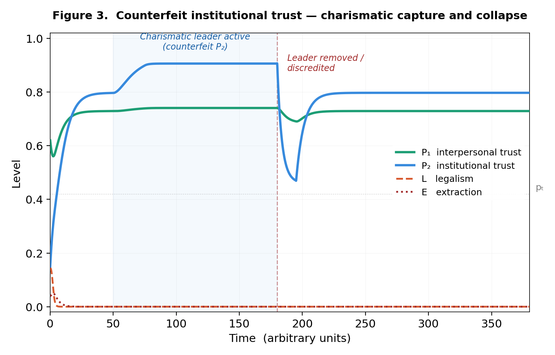

14. Hysteresis and Irreversibility
The collapse threshold is higher than the recovery threshold. Four mechanisms drive this:
Capacitance depletion. Moral reserves consumed during collapse leave the system unable to sustain recovery.
Moral skill atrophy. Generations raised under legalism never develop self-regulation. Lewis’s men without chests cannot be given chests by legislative action.
Network fragmentation. Islanding (Section 7.1) destroys long-range bonds, producing structurally lower effective k and weaker coupling on the recovery path.
Institutional lock-in. Legalist infrastructure creates constituencies that resist reduction through structural self-preservation.

15. The Ratchet, the Throttle, and Counterfeit Trust
(1) Perturbation reduces P₁.
(2) Legalism rises.
(3) Legalism erodes P₁ further; natural decay continues.
(4) Capacitance depletes.
(5) Extraction accelerates.
(6) Institutional constituencies resist reversal.
(7) Return to step (2).

The only endogenous brake is −φP₁E. Once the system reaches critical velocity, it consumes itself—a meltdown that cannot be arrested from within.
Counterfeit institutional trust arises when a charismatic figure reconstitutes P₂ through personal devotion rather than distributed accountability. Institutional trust does not have to be real to function—it only has to be believed. There is an old saying in bureaucracies: people’s perception is, to them, reality. Nobody personally audits the court system. Nobody individually verifies that regulations are applied equally. People believe institutions are legitimate, and that belief produces cooperative behavior indistinguishable from what genuine legitimacy would produce—until the moment it doesn’t.
Counterfeit P₂ poisons the medium of exchange. When the fraud is discovered, the crash destroys not merely trust in that leader but trust in the concept of institutional trust itself. People learn that institutional legitimacy can be faked—and that lesson transmits culturally, making future organic P₂ harder to build.

16. The Law at Both Extremes
In the moralist regime, law is a scalpel for psychopaths. In the legalist regime, law metastasizes until the most conscientious citizen is technically in violation. This is not failure—it is the system’s purpose. When everyone is technically guilty, enforcement becomes selective. The honest are most trapped; the predator treats complexity as camouflage.

17. A System of Trust-to-Wealth Conversion
Institutional power functions as a system of trust-to-wealth conversion. When P₁ is high, cooperative surplus is large—transactions are cheap, coordination is efficient, prosperity is distributed. Extraction captures this surplus through regulatory intermediation: every compliance requirement, licensing regime, and bureaucratic checkpoint is a toll on cooperative activity.
Because interpersonal trust is non-renewable on civilizational timescales, this conversion is mining, not harvesting. This is why collapsed civilizations stay poor. The geography remains. The resources remain. The trust mine is empty.

18. The Reduced Parameter Set
The original sixteen parameters reduce to nine dimensionless groups:
Parameter | Name | What it asks
k | Cultural susceptibility | How sharply does the society snap between regimes?
pₜ | Critical threshold | At what trust level does the regime flip?
ω | Trust weighting | How dominant is P₁ relative to P₂?
ν₂/ν₁ | Institutional stickiness | How much slower do institutions decay than personal trust?
ε/ν₁ | Legalist amplifier | How much faster does legalism erode trust than natural decay?
κ₁₂/κ₂₁⁰ | Coupling asymmetry | How much stronger is the P₁→P₂ channel?
β/α | Crash asymmetry | How much faster does P₂ collapse than P₁?
δ/λ | Irreversibility ratio | How much faster does capacitance drain than charge?
ξ/φ | Extraction balance | Does extraction outpace moral suppression?

The irreversibility ratio δ/λ controls hysteresis width. The extraction balance ξ/φ determines whether the engine runs away. When ξ/φ exceeds unity at current P₁, the meltdown is underway.

19. Falsifiable Predictions
1. P₂ collapses faster than P₁ once extraction is detected (β/α ≫ 1).
2. Counterfeit P₂ collapses faster than organic P₂.
3. High-capacitance societies show delayed but sharper transitions.
4. Regulatory density predicts declining interpersonal trust with a lag proportional to capacitance.
5. Hysteresis loop width scales with δ/λ.
6. The Milgram compliance rate should vary inversely with P₁ᵢ strength of the subject population—subjects from high-P₁ᵢ communities (strong family structure, strong religious formation) should show lower obedience to institutional authority than subjects from low-P₁ᵢ backgrounds.
7. The Pareto ratio of conscious extractors to compliant operators should be approximately constant across legalist systems regardless of culture, ideology, or historical period, because it is a property of network topology rather than population characteristics.

20. Scope and Limitations
Legalism sometimes creates trust. κ₂₁ > 0 when E < 0.5. The claim is not that institutions are inherently destructive but that they become so past the extraction tipping point.
Direct measures of P₁ₒ remain noisy. Outsider trust is the most consequential variable but the hardest to measure. Survey instruments lag economic signals by months to years.
The Pareto ratio is approximate. The 80/20 figure is illustrative. The precise distribution depends on network topology, institutional structure, and cultural factors. The structural claim—that a small minority of high-leverage actors drives the system while a large majority passively maintains it—is more robust than the specific ratio.
The model is a framework for discernment, not prescription. Any formal model of trust dynamics can be misappropriated for social engineering. The observer effect (Section 3) means this paper is a perturbation to the system it describes. Discernment is the only epistemological stance that respects both the model’s power and its danger.

21. Conclusion
“If the people be led by laws, and uniformity sought to be given them by punishments, they will try to avoid the punishment, but have no sense of shame.”
— Confucius
“When plunder becomes a way of life for a group of men in a society, over the course of time they create for themselves a legal system that authorizes it and a moral code that glorifies it.”
— Bastiat
Twenty-five centuries separate these observations. They describe the same system.
Carneades saw both regimes in two days and mistook them for a paradox. The model reveals they are two states of a single dynamical system—one governed by conscience, the other by compliance—separated by a critical threshold that, once crossed, produces a self-reinforcing cascade that history suggests is effectively irreversible.
The model’s most consequential insight is structural: the variable that matters most—interpersonal trust, built through family, religion, and culture over generations—is the one nobody is watching. Its erosion does not look like a crisis. It looks like modernization. The society looks strongest at the exact moment it becomes most fragile.
Milgram and Zimbardo proved that the transition can be compressed to minutes when institutional pressure is sufficient. The Pareto structure shows that the apparatus needs only a small minority of conscious actors to operate. The cultural capture mechanism ensures that even the stories a society tells itself reinforce the legalist frame. And the extrapolation error means the average person—surrounded by decent, trustworthy neighbors—has no mechanism to detect that the system above them has been captured until the moment of collapse.
The seeds of any recovery are planted not in policy but in moral formation. Families, communities, religious traditions, and the daily practice of trusting and being trustworthy charge capacitance, raise P₁, and provide the only endogenous brake on extraction. They cannot be legislated into existence.
This paper is offered as a framework for discernment—an aid to seeing clearly what is happening, so that those with eyes to see may act according to their conscience. The mathematics describe the dynamics. The outcome depends on forces—moral, cultural, and perhaps transcendent—that lie beyond the scope of any formal system.

